MINISTRY OF EDUCATION AND SCIENCE OF UKRAINE

NATIONAL TECHNICAL UNIVERSITY

“KHARKOV POLYTECHNICAL INSTITUTE”

LABORATORY WORK № 1

# “Basic concepts of programming. Design and Graphical Representation of Algorithms”

Created by student of 1.КН.201.8г

Ohol K.V

Tutor

Melnik K.V

KHARKIV 2018

Topic: Creating and graphic submission with using Visual Paradigm for UML.

Goal: Learning Use Case and Activity Diagrams by using Visual Paradigm for UML.

Tasks:

1. Get the task and analyze the computational algorithms.

2. Develop the Activity diagram.

3. Develop the Use Case diagram.

4. Prepare the report of the work

Progress of the lab

1. Get the task and analyze the computational algorithms.

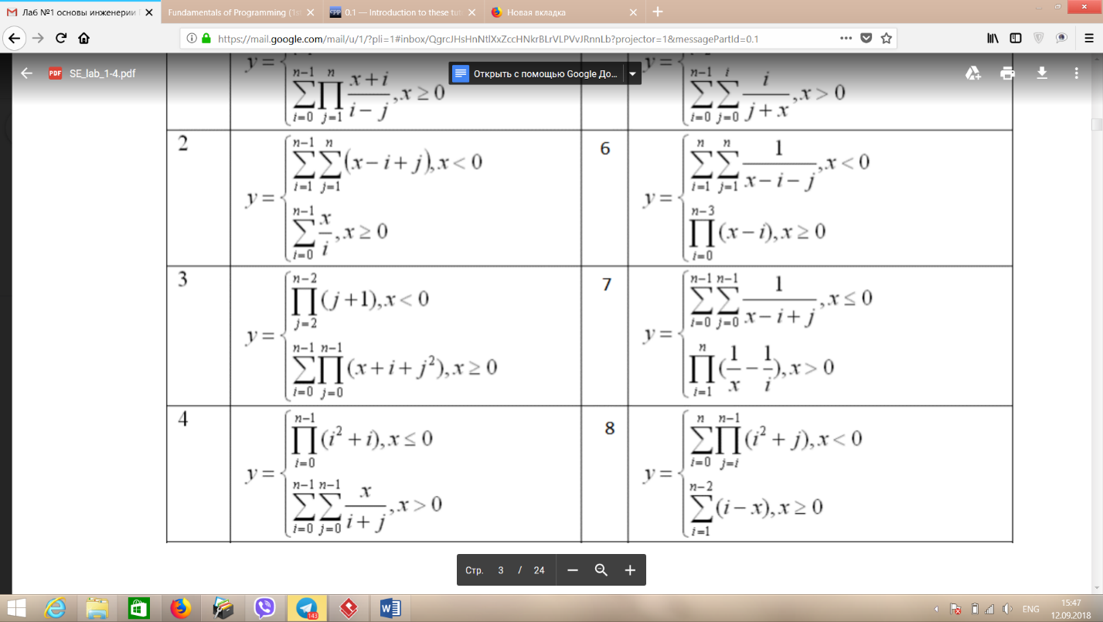

2. Develop the Activity diagram.

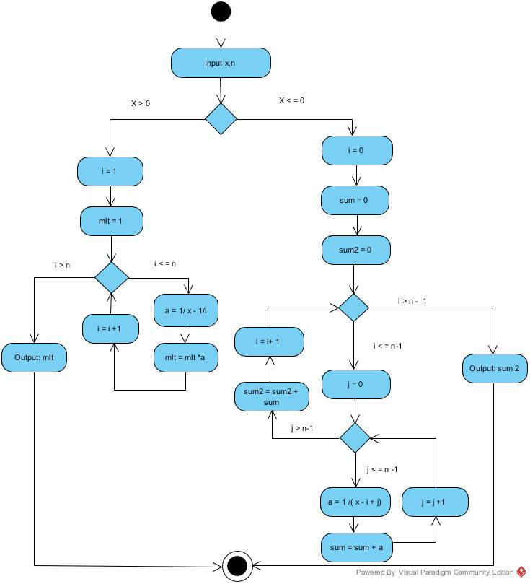

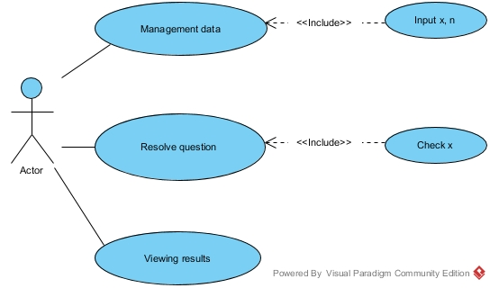3. Develop the Use Case diagram.

Conclusion: I received practical skills of work with Visual Paradigm for UML. I was informed about recommendations on use Visual Paradigm for UML. It learned how to create activity diagrams and use-case diagrams on the decision of tasks.